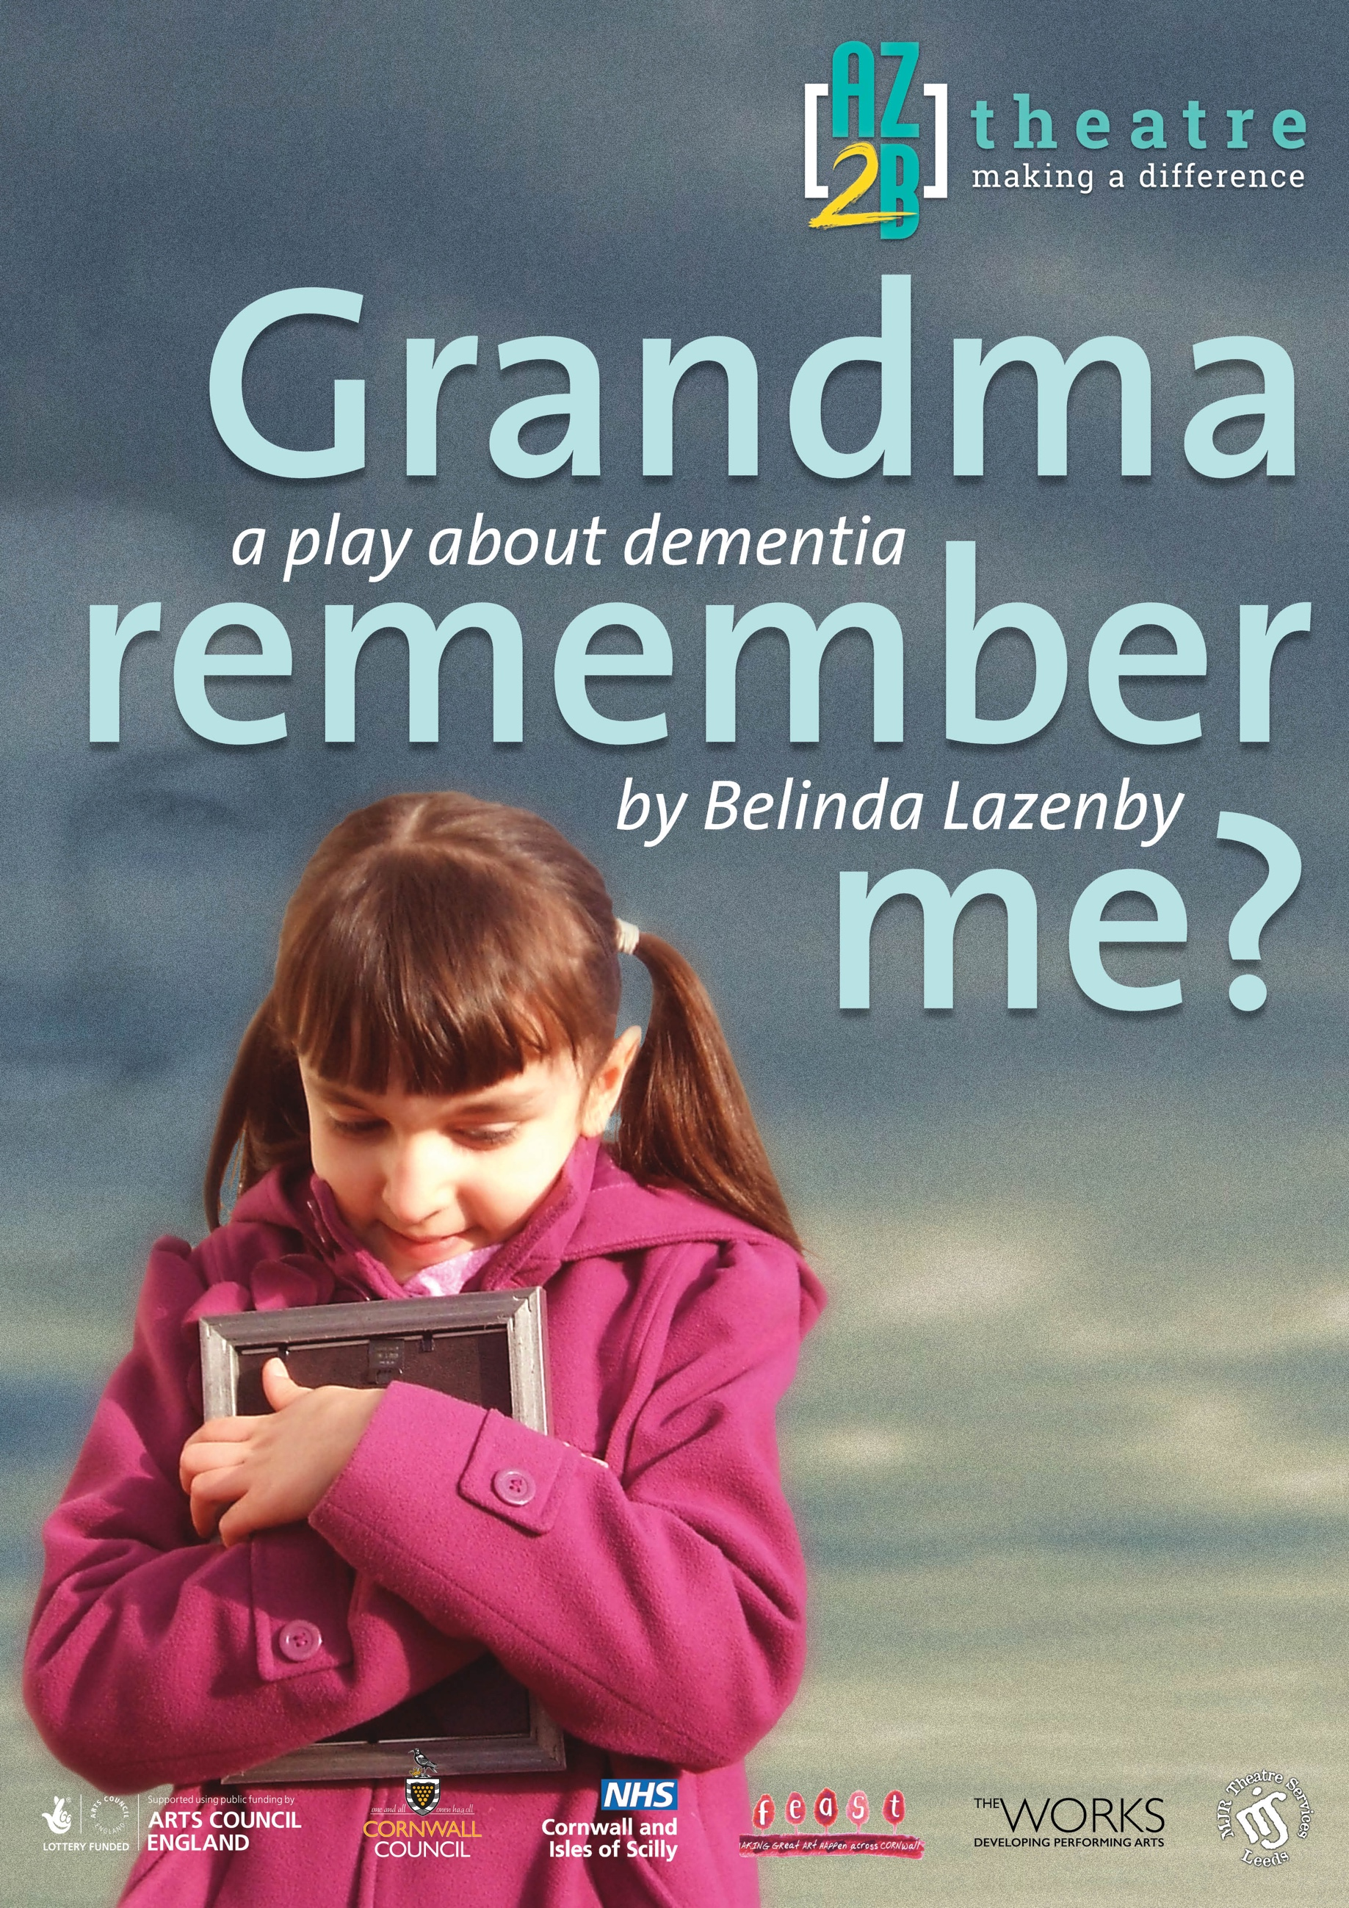

**SATURDAY   
18th SEPTEMBER 2021**

**11 AM**

**STAGE TWO**

**THEATRE ROYAL**

**Theatre Street • Big City • AB1 2CD**

**Box Office Tel: 01234 567 890  
£10 Adult | £6 Child**