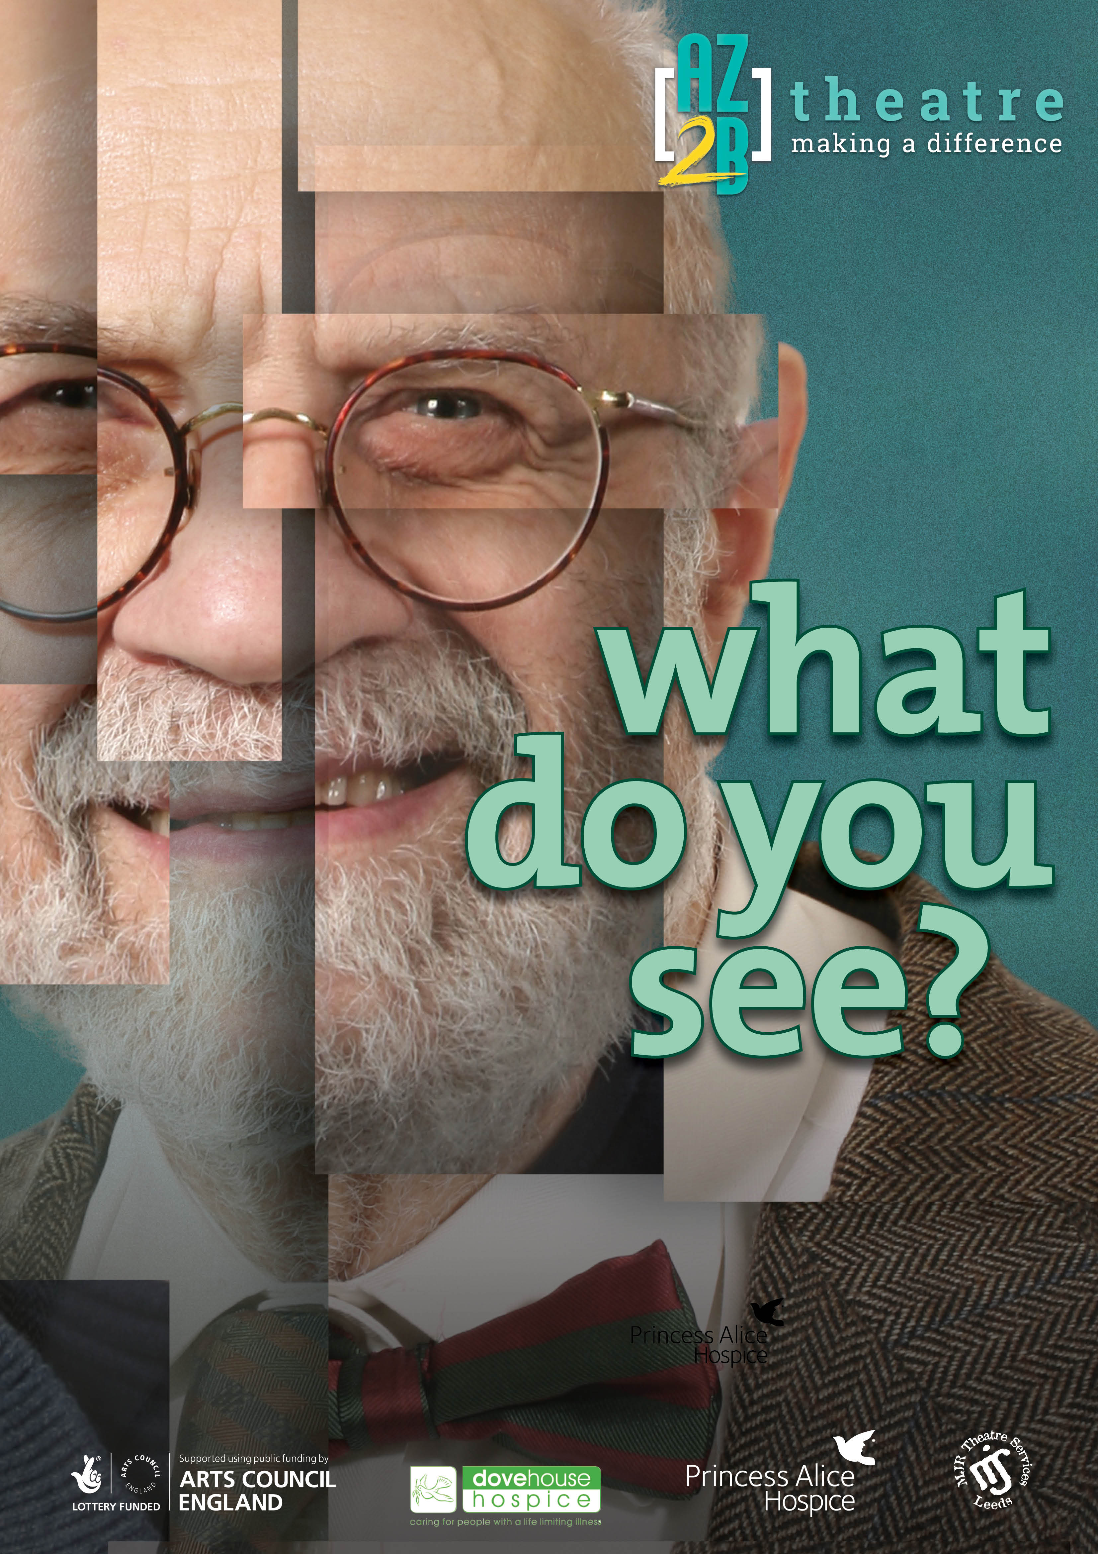

**STAGE TWO**

**THEATRE ROYAL**

Theatre Street • Big City • AB1 2CD

Box Office Tel: 01234 567 890

**SATURDAY  
18th SEPTEMBER 2021**

**11 AM**

£10 Adult | £6 Child